Cloudinary

for Page Designer

*Version 24.1.0*



**Table of Contents**

1. Summary 3

2. Setup 3

Setup of Business Manager 3

Installing the cartridges to the sandbox 3

Assigning the cartridges to relevant sites through the Business Manager 4

Importing meta-data and services 5

Configuration 7

Configuring Cloudinary credentials and other settings in the Business Manager 7

3. User Guide 7

Storefront Functionality 7

4. Testing Status 7

5. Operations, Maintenance 7

Availability 7

Support 7

6. Release History 8

# Summary

The Cloudinary Page Designer cartridge contains the Cloudinary image and video components for Page Designer. The Cloudinary image and video components enable you to access your Cloudinary media library to select assets to embed in pages created using the Page Designer. Apply Cloudinary transformations to your assets, either globally to all assets, or individually to specific assets, to achieve the exact image and video experience that you desire.

# Setup

## Setup of Business Manager

# Installing the cartridges to the sandbox

There are two cartridges that need to be installed.

1. Download the **bm_cloudinary_pd** and **int_cloudinary_pd** cartridges.
2. Open Demandware Studio.
3. Import both cartridges from the **Import** dialog:

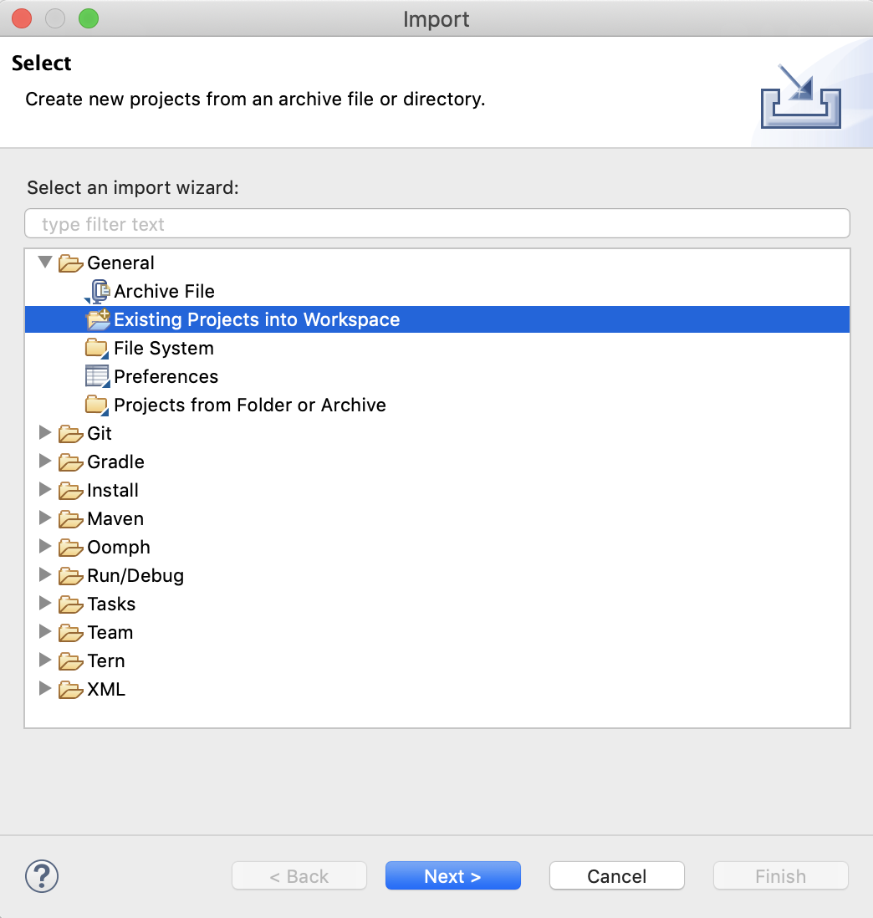

1. **Link** the cartridges to the sandbox. Select the sandbox connection and then select **Properties**. Select **Project Reference** and check in.

# Assigning the cartridges to relevant sites through the Business Manager

1. Log in to the Business Manager.
2. Navigate to **Administration** > **Manage Sites** (under Sites).
3. Select the **Business Manager** site**.**
4. Add bm_cloudinary_pd to the cartridge path as shown:

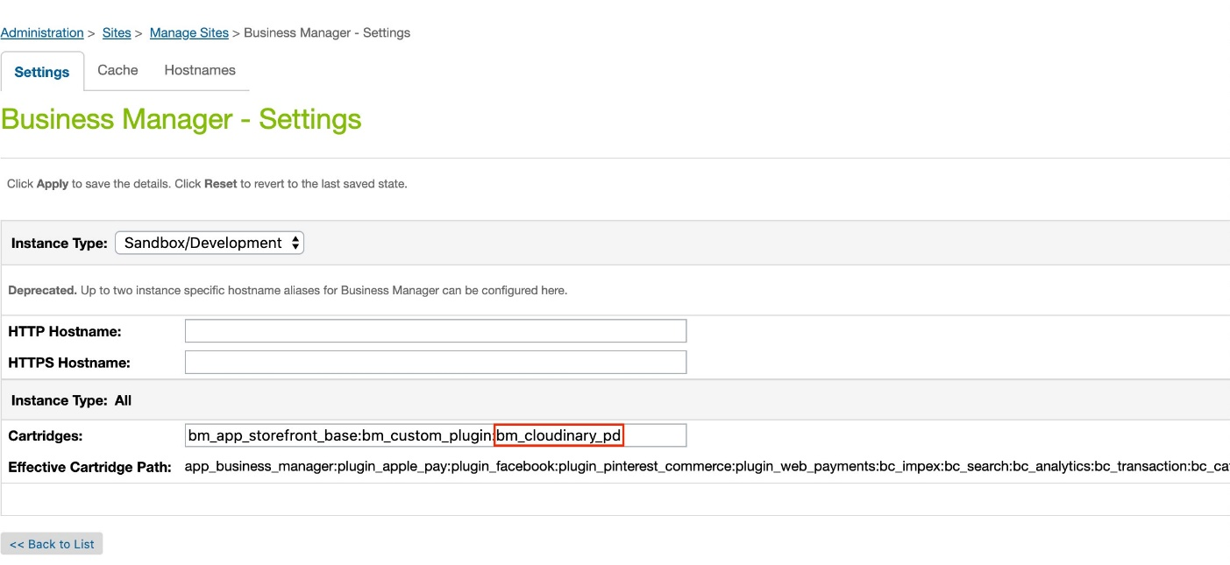

1. Apply the changes.
2. Navigate back to **Manage Sites.**
3. Select the storefront site for which you want to enable the Cloudinary image and video components. Navigate to the **Settings** tab.
4. Add int_cloudinary_pd to the cartridge path as shown:

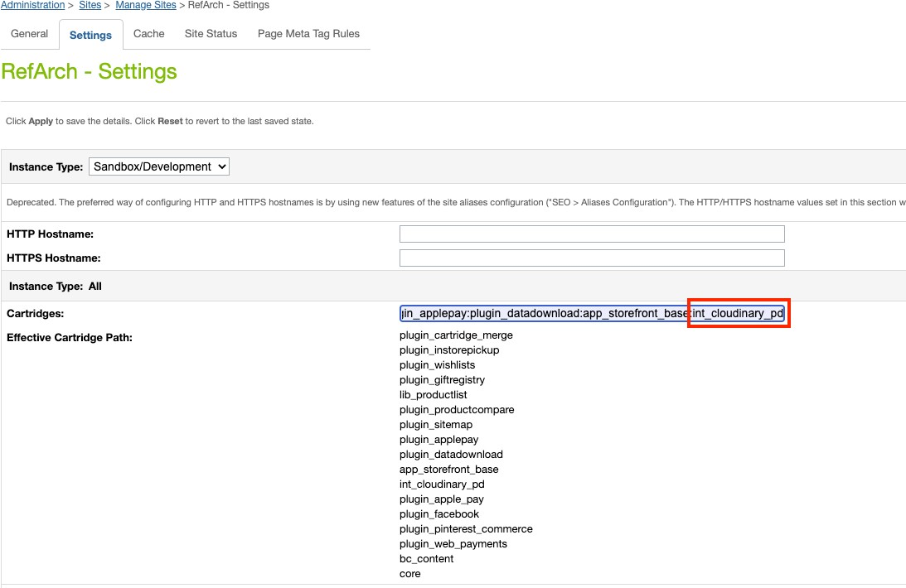

1. Apply the changes.

# Importing meta-data and services

1. In the Business Manager, navigate to **Administration** > **Site Development** > **Site Import & Export**. Choose **Upload**. Select **import.zip** from the **metadata** folder of the repository.

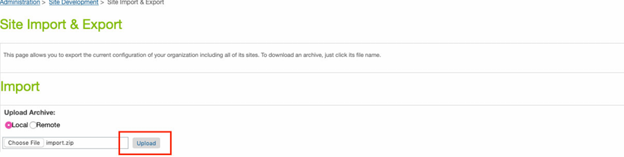

1. Select the radio button next to **import.zip**. Click the **Import** button.

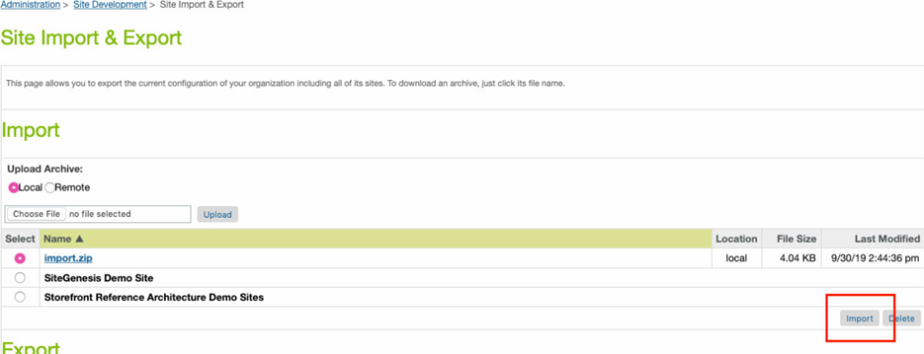

1. Click **OK**.

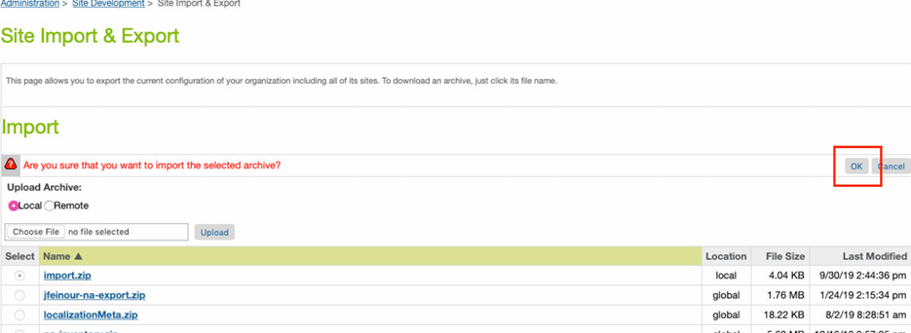

1. Navigate to **Administration > Operations > Services**.
2. After successful import of metadata the **cloudinary.https.api** service is added. In the service’s credentials add the following details:
   * **URL**: https://api.cloudinary.com/v1_1/{cloud_name}
   * **User**: Your API Key
   * **Password**: Your API Secret

You can find your cloud name, API Key and Secret in your Cloudinary console Dashboard, at <https://console.cloudinary.com/console>.

## Configuration

# Configuring Cloudinary credentials and other settings in the Business Manager

You can watch the video tutorial to Configuring Cloudinary credentials and other settings in the Business Manager

<https://cloudinary.com/documentation/salesforce_page_designer_cartridge_integration#page_designer_cartridge_video_tutorial>

# User Guide

You can find the user guide at:

<https://cloudinary.com/documentation/salesforce_page_designer_cartridge_integration>

## Storefront Functionality

*There is no storefront functionality.*

# Testing Status

The Cloudinary Page Designer cartridge is supported for en_US and was tested against:

* B2C Commerce Version: 20.6 (Compatibility Mode: 21.2)
* SFRA 7.0.0

# Operations, Maintenance

## Availability

The status of Cloudinary’s services can be found on our service status page -

https://status.cloudinary.com/. From here, you can subscribe to service status updates.

## Support

Contact our support team if you have any issues with the cartridge. <https://support.cloudinary.com/hc/en-us>

# Release History

|  |  |  |
| --- | --- | --- |
| **Version** | **Date** | **Change** |
| 19.1.0 | 2019-08-15 | Initial release |
| 20.1.0 | 2020-08-07 | Added image component and updated video component. |
| 24.1.0 | 2024-01-31 | Upgraded the Cloudinary Video Player to v1.10.4.  Added Support for [video analytics.](https://cloudinary.com/documentation/video_analytics)  Implemented user-agent and analytics tag functionality.  Addressed an issue related to link removal from assets. |